# TESTTEST

# Instructions for accessing network printers via Windows

To access a network printer, your computer will need to be logged into the UNIWA domain or your UNIWA domain credentials saved to your profile.  
  
If you require assistance at any stage of this process, please contact IT Support via email at   
[ithelp-ecm@uwa.edu.au](mailto:ithelp-ecm@uwa.edu.au)

#### Step 1

To find out if your computer is alreadyconnected to UNIWA, check your Windows login screen for the word ‘UNIWA’ as shown below.  
  
*If you are connected to UNIWA, skip ahead to Step 5.*

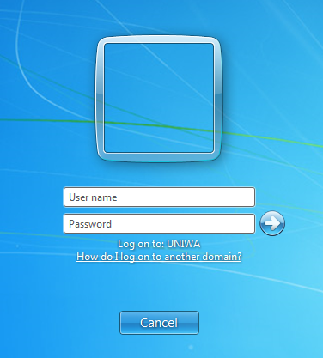

#### 

#### Step 2

For computers not connected to UNIWA, click the Start Button or press the [Windows Key] and type ‘Credential Manager’ in the text box labelled *‘Search programs and files’* as shown below.

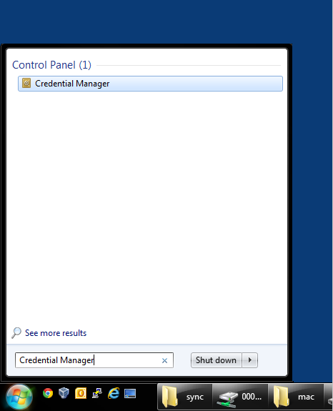

#### Step 3

Then click on “Add a Windows credential”.

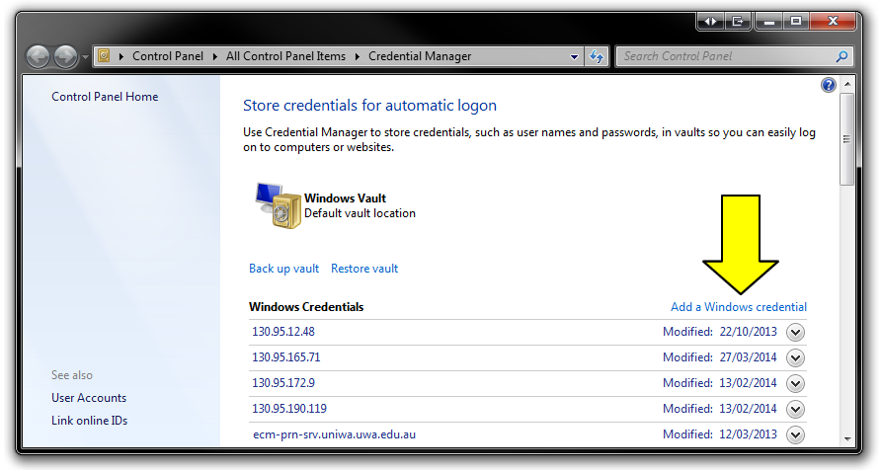

#### Step 4

Now enter the following information below and click OK.

**Internet or Network Address:** \\ecm-prn-srv.uniwa.uwa.edu.au

**User Name:** uniwa\[Staff or Student number]

**Password:** [Your Pheme Password]

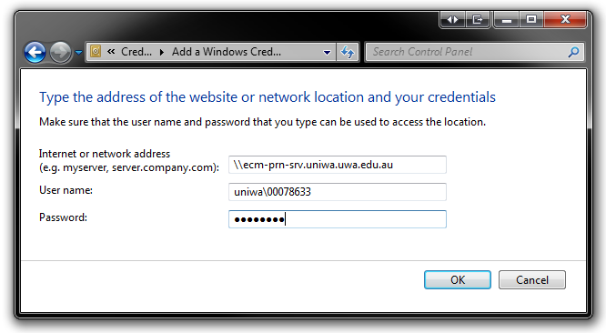

#### Step 5

Click the Start Button or press the [Windows Key] and enter the Print Server address in the text box labelled *‘Search programs and files’*

**Print Server address:** \\ecm-prn-srv.uniwa.uwa.edu.au

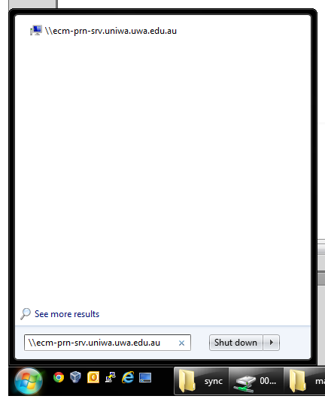

#### Step 6

Select (double click) the printer/s you wish to add from the list that appears to install the Printer to your computer.

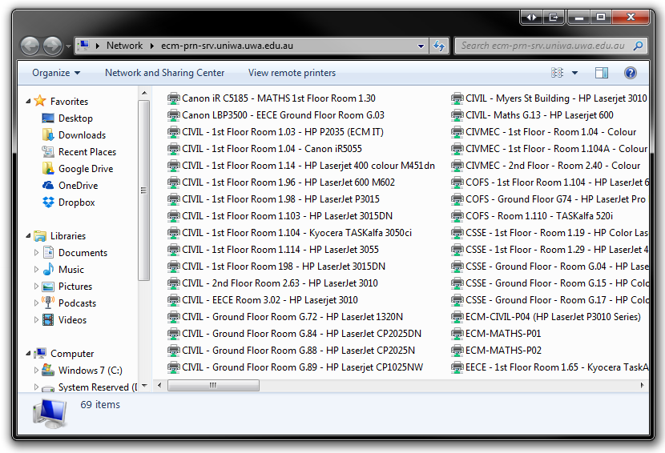

To assist with making your selection, printers are organised byBuilding, Floor, Room, and Printer model.

*Some printers are not accessible to all staff/students. If you encounter the message “Access Denied,” it means that you are not currently authorised to use that printer.   
  
If you believe you should have access, please contact ECM IT Support at*[ithelp-ecm@uwa.edu.au](mailto:ithelp-ecm@uwa.edu.au).

For example, to add the new CEME printers in the Civil Mechanical Building located on each floor, you would add the following:

* CIVMEC – 1st Floor – Room 1.04 – Colour
* CIVMEC – 1st Floor – Room 1.104A – Colour
* CIVMEC – 2nd Floor – Room 2.40 – Colour

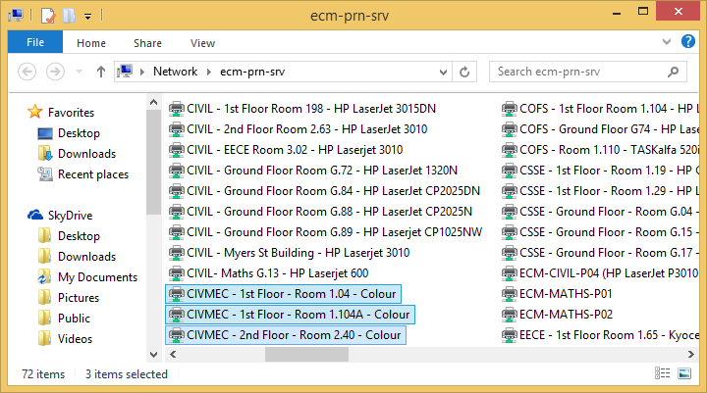

#### Step 7

After you have installed your printer/s, we recommend you test the printer connection by opening Microsoft Word and printing a sample document.

## Contacting ECM IT Support

For any issues, please contact your local ECM IT Support office.

Email: [ithelp-ecm@uwa.edu.au](mailto:ithelp-ecm@uwa.edu.au)

Electrical Engineering Room 3.09 Ext 7246

Civil & Mechanical Engineering Room 1.03 Ext 1999

Computer Science Room G.04 Ext 7082